**SNAPSHOT CREATION:**

1. Steps which we followed for EC2-Linux instance, replica it for windows instance as well. So now I have created EC2-windows Instance.

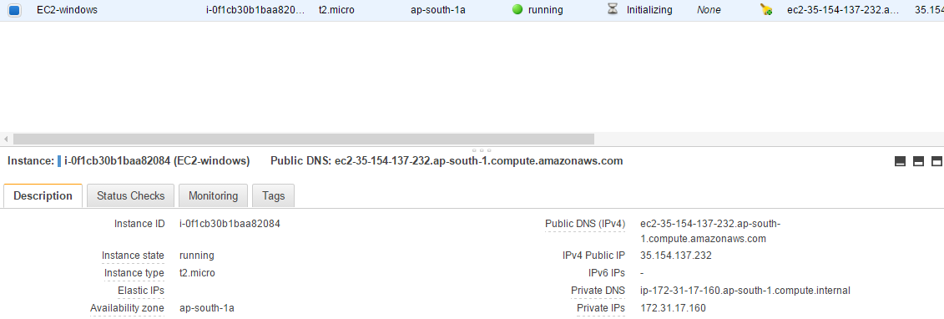

SCENARIO:1 : WE NEED TO MODIFY THE VOLUME WITH THE DATA.

1.Connect to ec2 windows instance.

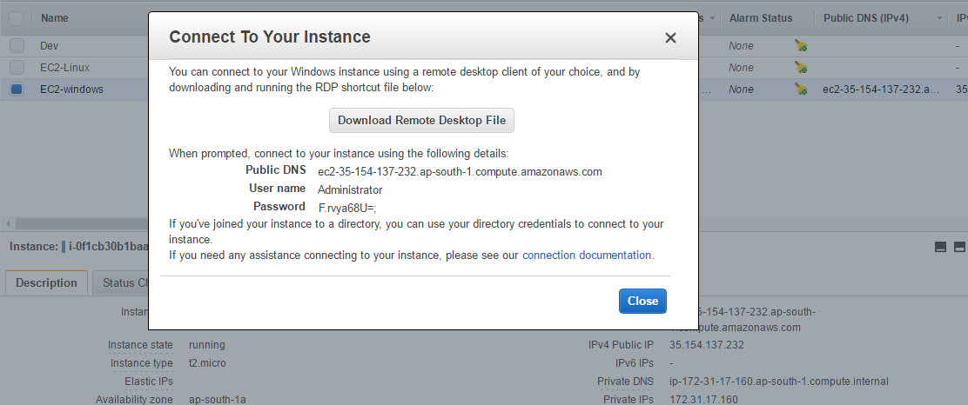

2.You will find extra volume as we have choosed add new volume while creating ec2 instance.

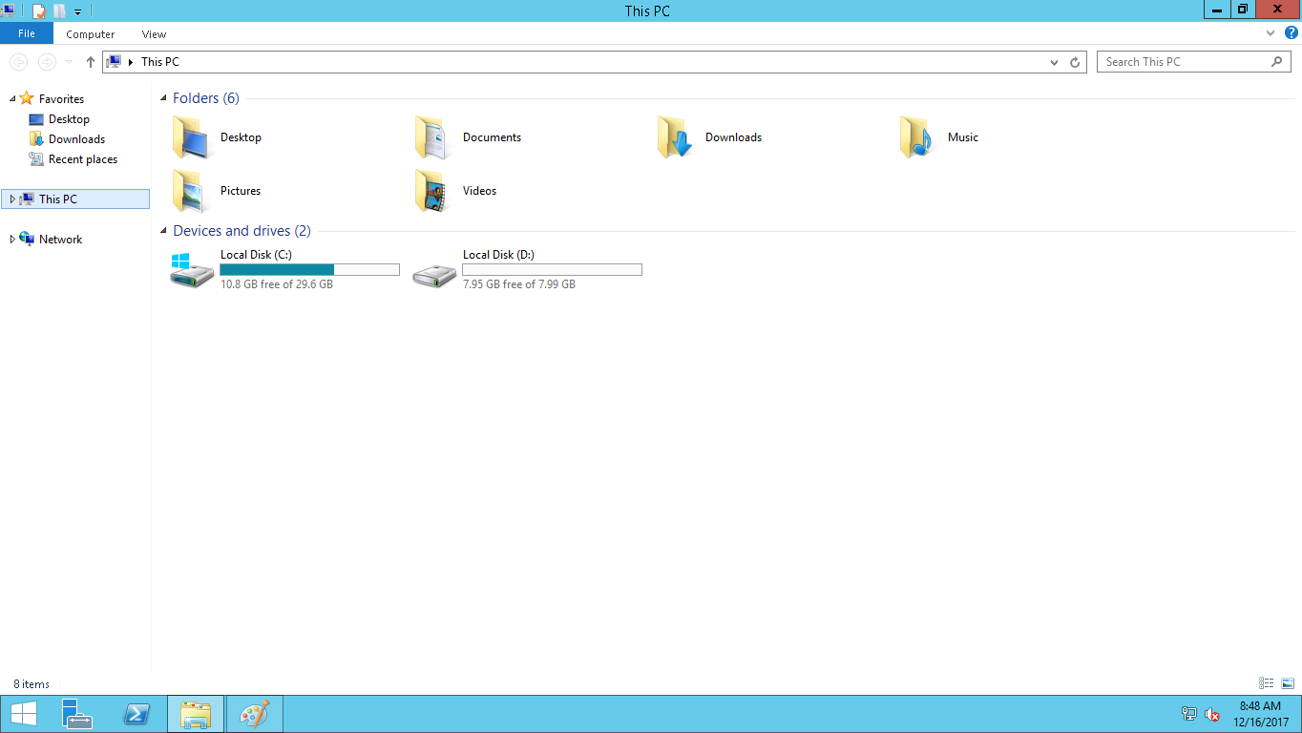

3. create one new doc in D: drive.

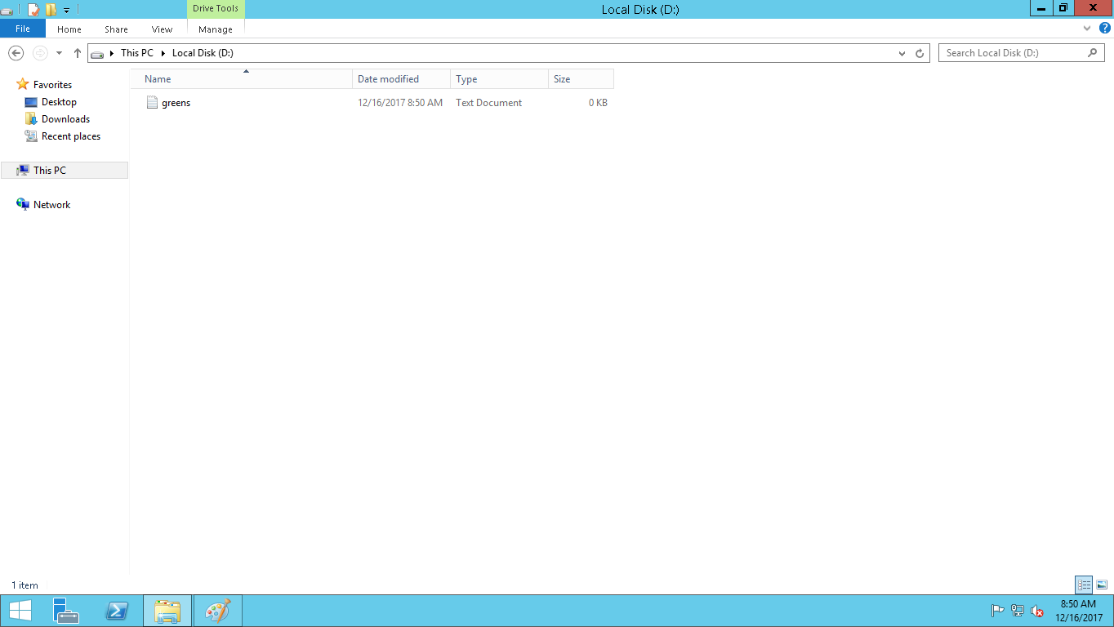

4.All your volumes of ec2 instance will be there under elastic block storage section as below

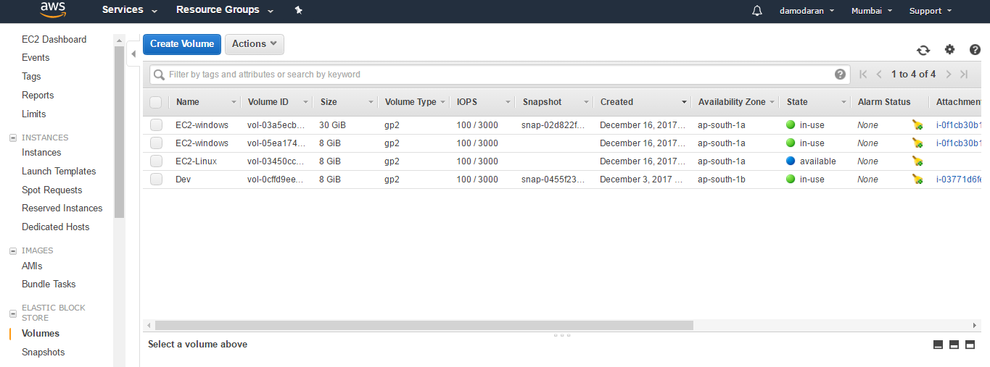

5.choose the ec2 instance where you have kept the data. Go to actions, modify volume, change the size as per your wish max is 16TB

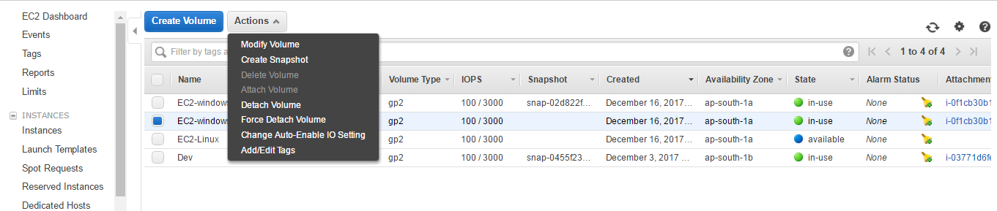

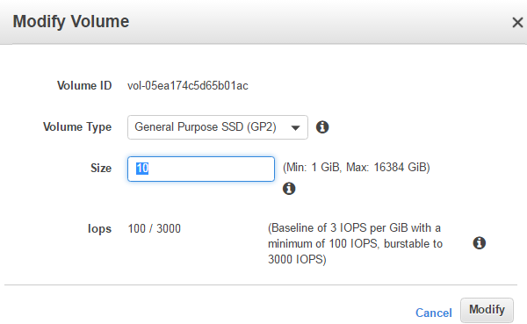

6.Click Modify .Refresh the page, Now you will see the volume size will be changed.



7.Again connect to ec2 instance. Go to programs, right click the mouse, you will find disk management .

8.Click refresh.

9.Right click in Primary partition,choose extend volume. Click next

10.Now the volume will be changed with data

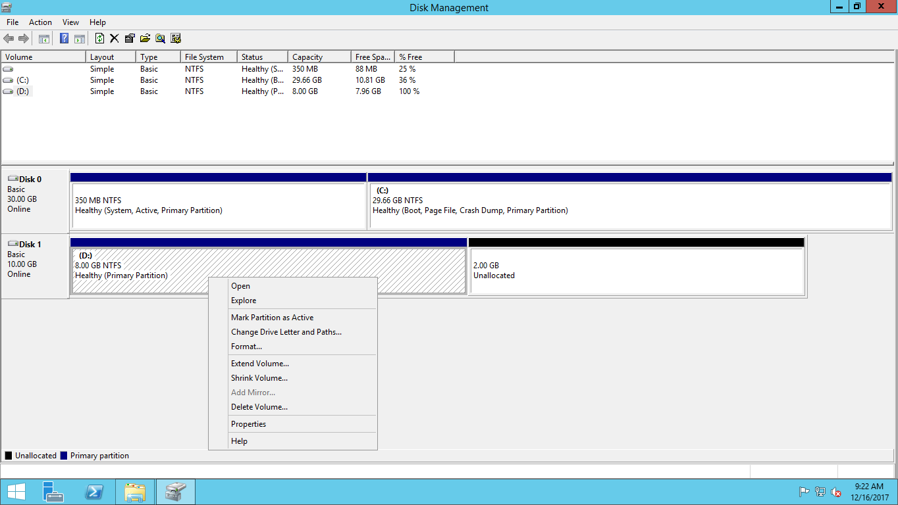

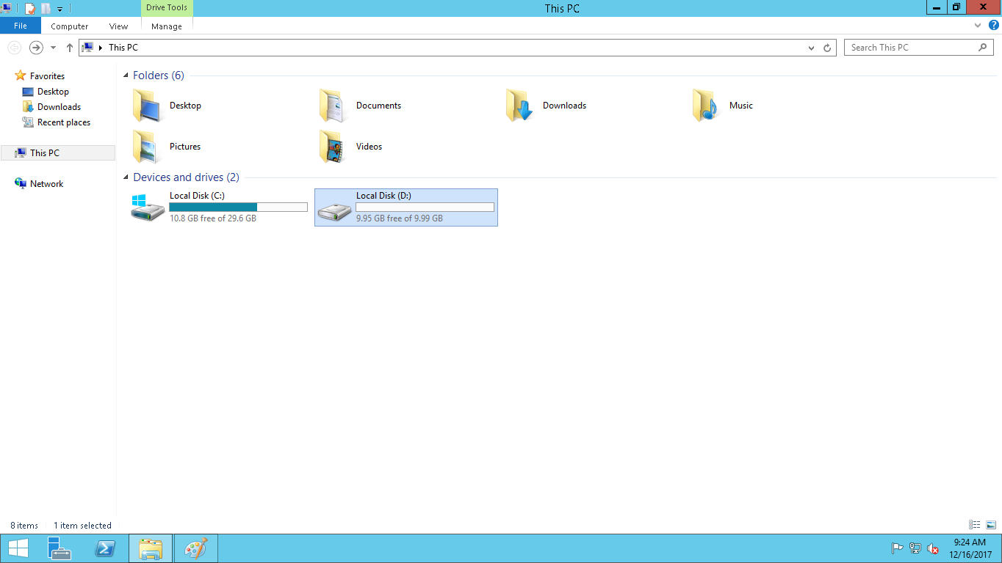

SCENARION 2: Move the data from one instance to another

1.Go to Volume which is under elastic block storage.

2.Choose the ec2 instance volume where your data's are stored. Click actions ,create snapshot and give some name for your snapshot

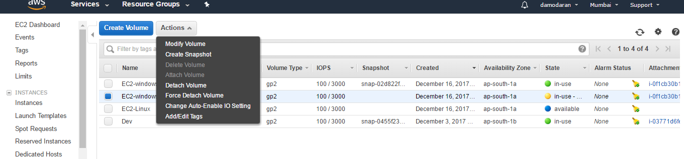

3.Snapshot will be created under elastic block storage section. Note down snapshot id

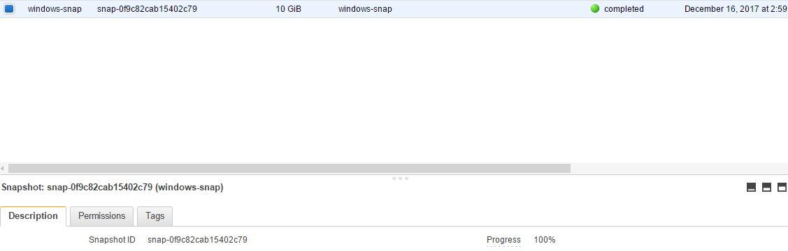

4. Launch the ec2 instance. Follow same step 1,2,3 as per previous docs

5.Go to step 4. Click add volume and give snapshot id in snapshot field

ur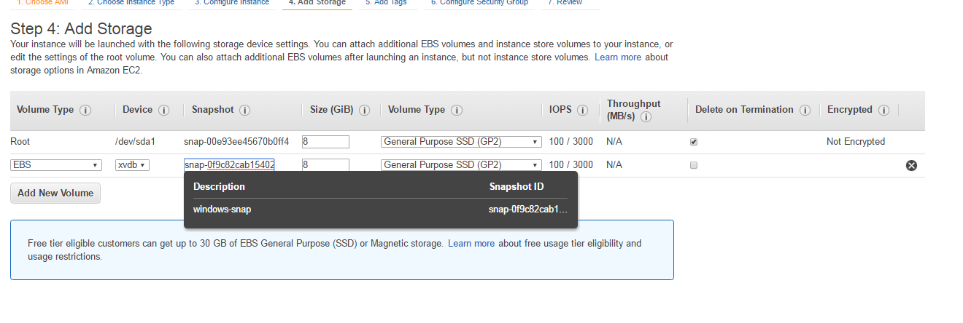

6.Then follow same steps and launch your ec2 instance

7.connect ec2 instance

8. Go to programs, right click the mouse, you will find disk management .

9.Click refresh.

10.Left click on offline,make it online

